"SnakeBody - EllipseRibPatterns

Designs are on pages 2 to 6, to print, then paste on plyword to cut and drill.   
This page is for change documentation, measurement details and MS Word drawing sub groups.

Change documentation

|  |  |  |  |
| --- | --- | --- | --- |
| Version | Date | Who | Notes |
| v20170103 | 03 Jan 2017 | JPC | 1. Change rib size from 80mm x 64mm to 80mm x 66mm to make sure of fitting MG90 servos inside the rib edge. 2. Change cable holes from 6mm dia (1/4 inch) to 8mm dia (5/16 inch) 3. Move cable holes further from the centre - hole centre now at 21mm horizontal and 14mm vertical. |

Measurement Details

Cable routing  
hole - 8mm dia

Ruler  
21 x 14

Rectangular cutout holes to locate servos

Central tube spine hole - 4mm dia

Ruler  
15.5 x 10

MS Word Drawing Elements for reuse including rib and hole subgroups.

Top

Print.   
Rib design size is 80mm x 66mm - check that on printing.   
Cut-out the "Head" and "Ribs".  
Glue to 3mm (1/8 inch) craft plywood with PVA then cut out.  
See photos and notes at the end of this document.  
TODO - upgrade to 3D printing for these.

Ruler  
21 x 14

Head piece or "neck"  
Holds the head items.

Top

Ruler  
8 x 8

Ruler  
15.5 x 10

2

1

HEAD

Under discussion:   
making this smaller than the "Ribs"

Rib01

Top

Ruler  
21 x 14

Note that Ribs all have a 4mm hole  
(5/32 inch) drilled in the centre.

The offset hole is 6mm (1/4 inch)  
for running cables through.

Compare with Rib02 below  
to see how we aim  
to "balance" the weights   
of the servos by   
staggering their positions  
rib by rib.

Rib02

Ruler  
15.5 x 10

Top

1

Rib03

Top

Top

4

3

Ruler  
21 x 14

Top

Rib04

5

Rib05 is a Battery Holder.   
The horizontal movement servo  
mounts in the top of the rib  
to make space at the bottom  
for the battery.

Ruler  
15.5 x 10

Top

Rib06

7

6

Ruler  
21 x 14

Rib07

Top

Rib08 is the second Battery Holder.   
The horizontal movement servo  
mounts in the top of the rib  
to make space at the bottom  
for the battery.

Top

8

Rib09

10

9

Ruler  
21 x 14

Top

Rib10

Top

Notes.   
Cutting out worked best for me with my basic home workshop resources by:

1. Rough cutting out with a power jigsaw
2. Working around the edge with a sanding disc attachment for my electric drill
3. Taking the pieces to my neighbour to borrow the use of his drill press   
   to drill the holes accurately - thanks Dave!

Note - Scraping away the paper design from the plywood so the servos stick better.

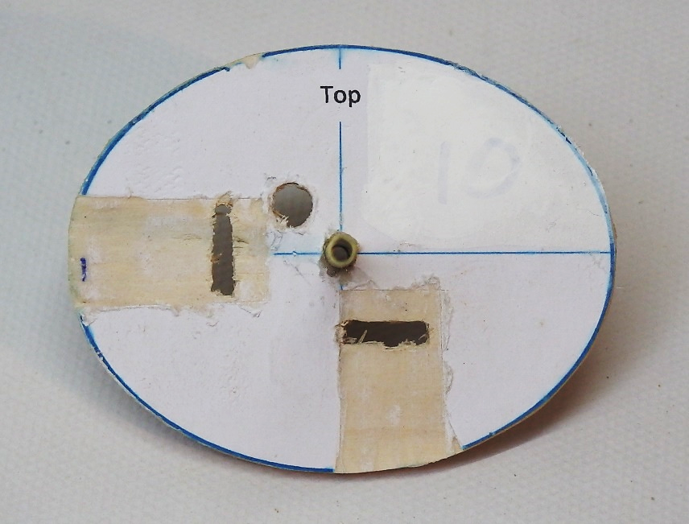

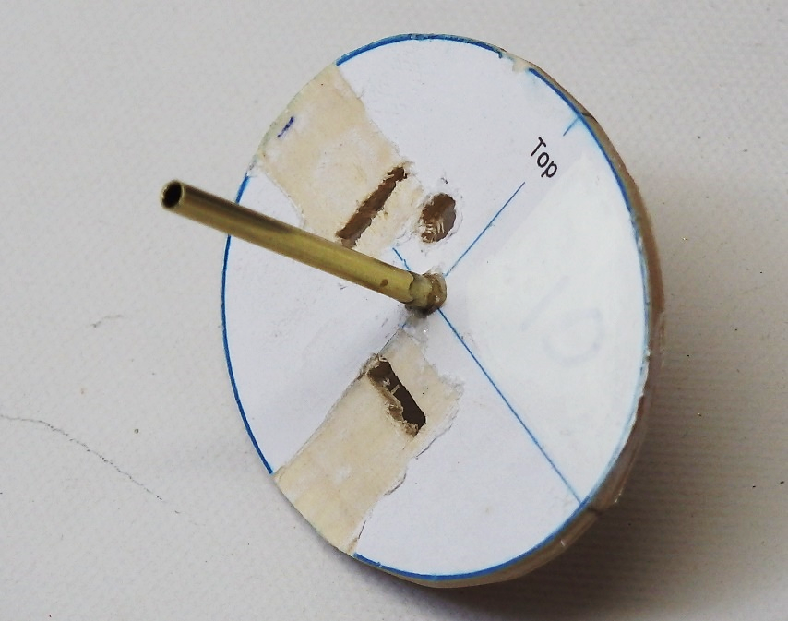

SG90 servos shown from my first build. I am now recommending MG90 servos.

